Module 6
1. Staircase | HackerRank
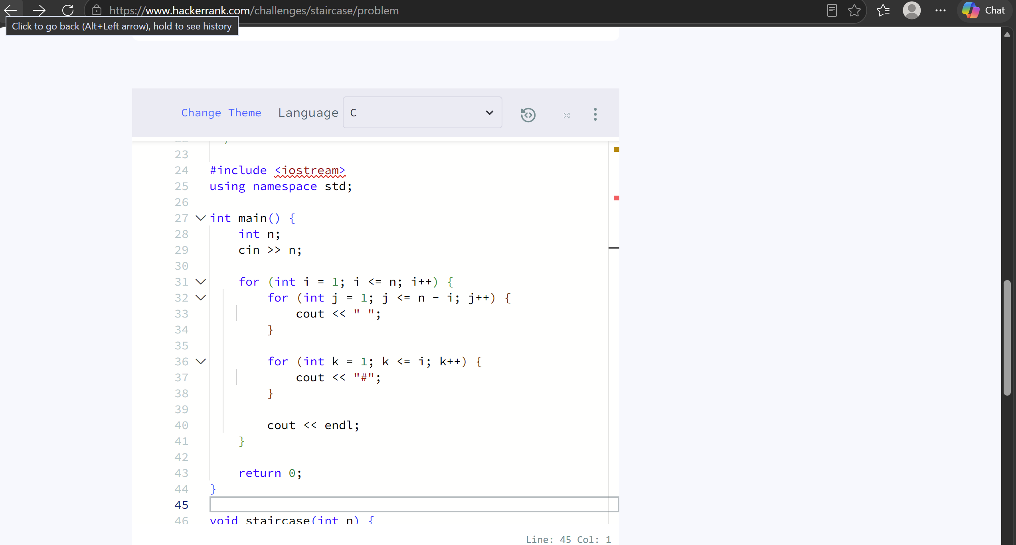
2. Printing Pattern Using Loops | HackerRank


